**LAPORAN HASIL PRAKTIKUM**

**DATA WAREHOUSE**

**JOBSHEET 2**



**Oleh:**

**DZULFIKAR MUHAMMAD AL GHIFARI**

**NIM. 2341760071**

**SIB-2B / 08**

**D-IV SISTEM INFORMASI BISNIS**

**JURUSAN TEKNOLOGI INFORMASI**

**POLITEKNIK NEGERI MALANG**

**TUGAS 1**

1. **Import data perusahaan tersebut pada DBMS MySQL!**

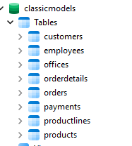

1. **Analisa struktur data dari database perusahaan tersebut, dalam bentuk tabel, analisa hubungan setiap tabel nya!**

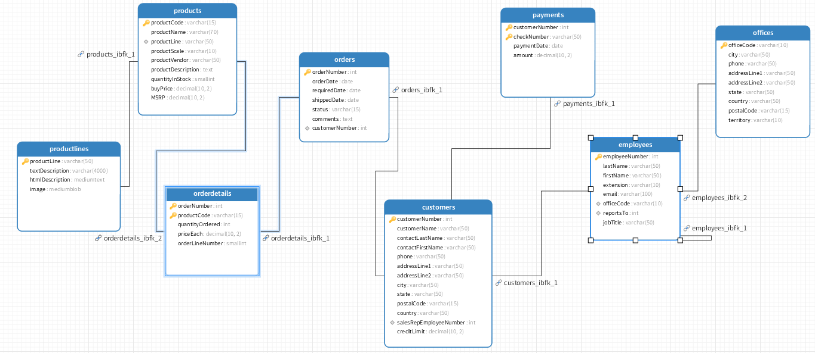

|  |  |  |
| --- | --- | --- |
| **tabel 1** | **tabel 2** | **jenis relasi** |
| productlines | products | One-to-Many (1:N) |
| products | orderdetails | One-to-Many (1:N) |
| orders | orderdetails | One-to-Many (1:N) |
| customers | orders | One-to-Many (1:N) |
| customers | payments | One-to-Many (1:N) |
| employees | offices | Many-to-One (N:1) |
| employees | employees | Hierarchical (Self-Join) |
| customers | employees | Many-to-One (N:1) |

1. **Analisa jumlah field pasa setiap table!**

|  |  |
| --- | --- |
| **Nama Tabel** | **Jumlah Field** |
| productlines | 4 |
| products | 8 |
| orderdetails | 4 |
| orders | 6 |
| customers | 9 |
| payments | 4 |
| employees | 7 |
| offices | 7 |

**PRAKTIKUM 1**

1. **Jalankan query berikut pada DBMS MySql yang telah tersedia data Perusahaan LegendVehicle.**

SELECT *

FROM employees employe, employes manager, customer cust

WHERE employee.reportsTo=manager.employeeNumber

AND employee.employeeNumber=cust.salesRepEmployeeNumber;

**maka hasil dari query tersebut adalah data Employee beserta Manajernya dan Customer yang ia miliki. perhatikan hasil data dengan seksama.**

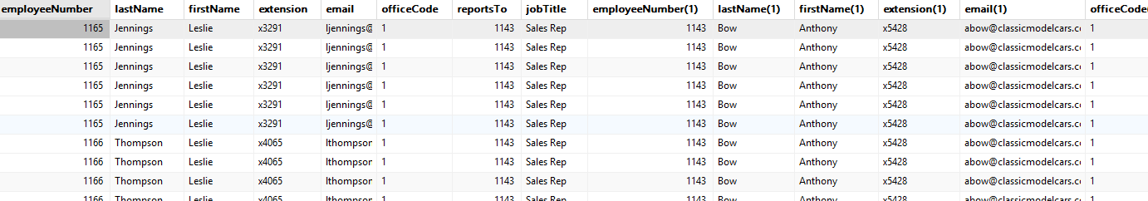

1. **Buka tab baru pada browser untuk melakukan eksekusi query berikut:**

SELECT manager.employeeNumber as id_manager,

CONCAT(manager.firstName," ,manager.lastName) as Manager,

employee.employeeNumber as id_staff,

CONCAT(employee.firstName," ",employee.lastName) as staff

FROM employees employee, employees manager

WHERE employee.reportsTo=manager.employeeNumber

ORDER BY manager.firstName;

**dari hasil query diatas maka akan ditemukan atasan dari setiap pegawai.**

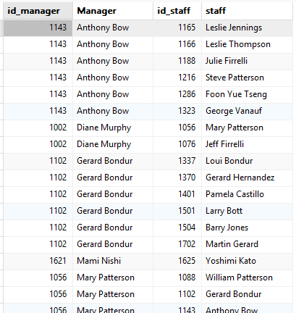

**TUGAS 2**

1. **Gambarlah hirarki organisasi berdasarkan atasan dari setiap pegawai sesuai dengan hasil prakatikum diatas!**

**Hierarki Organisasi**

* **Diane Murphy (1002)**
  + **Jeff Firrelli (1076)**
  + **Mary Patterson (1056)**
    - **William Patterson (1088)**
      * **Andy Fixter (1611)**
      * **Peter Marsh (1612)**
      * **Tom King (1619)**
    - **Gerard Bondur (1102)**
      * **Loui Bondur (1337)**
      * **Gerard Hernandez (1370)**
      * **Pamela Castillo (1401)**
      * **Larry Bott (1501)**
      * **Barry Jones (1504)**
      * **Martin Gerard (1702)**
    - **Anthony Bow (1143)**
      * **Leslie Jennings (1165)**
      * **Leslie Thompson (1166)**
      * **Julie Firrelli (1188)**
      * **Steve Patterson (1216)**
      * **Foon Yue Tseng (1286)**
      * **George Vanauf (1323)**
    - **Mami Nishi (1621)**
      * **Yoshimi Kato (1625)**

1. **Buka tab baru pada browser untuk melakukan eksekusi query berikut:**

SELECT manager.employeeNumber as id_manager,

concat(manager.firstName," ",manager.lastName) as Manager,

employee.employeeNumber as id_staff, concat(employee.firstName," ",employee.lastName) as staff,

count(cust.customerNumber) as total_cust

FROM employees employee join employees manager on employee.reportsTomanager.employeeNumber

left join customers cust on employee.employeeNumber=cust.salesRepEmployeeNumber

GROUP BY employee.employeeNumber

ORDER BY manager.firstName;

**dari query tersebut menghasilkan jumlah customer dari setiap staff.**

**Jika perusahaan tersebut memiliki KPI (Key Performances Indicator) "Jumlah customer yang bertransaksi" maka jawablah pertanyaan-pertanyaan berikut!**

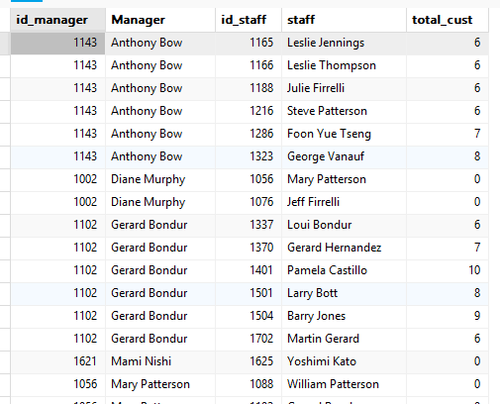

**TUGAS 3**

1. **Siapakah staff dengan hirarki paling bawah yang berprestasi dilihat dari jumlah customer terbanyak?**

SELECT

e.employeeNumber AS id_staff,

CONCAT(e.firstName, ' ', e.lastName) AS nama_staff,

COUNT(c.customerNumber) AS total_customer

FROM employees e

LEFT JOIN customers c ON e.employeeNumber = c.salesRepEmployeeNumber

WHERE e.employeeNumber NOT IN (SELECT DISTINCT reportsTo FROM employees WHERE reportsTo IS NOT NULL)

GROUP BY e.employeeNumber

ORDER BY total_customer DESC

LIMIT 1;

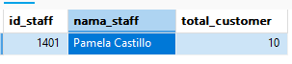

Pamela Castillo (1401) dengan 10 customer.

1. **Jika KPI atasan dihitung dari customer yang dimilikinya dijumlah dengan customer dari staff dibawahnya, urutkan ranking prestasi keseluruhan pegawai beserta keterangan jumlah customer yang dimilikinya!**

SELECT

manager.employeeNumber AS id_manager,

CONCAT(manager.firstName, ' ', manager.lastName) AS nama_manager,

COUNT(DISTINCT cust.customerNumber) AS total_customer_direct,

COALESCE(SUM(subordinate.total_customer), 0) AS total_customer_bawahan,

(COUNT(DISTINCT cust.customerNumber) + COALESCE(SUM(subordinate.total_customer), 0)) AS total_kpi

FROM employees manager

LEFT JOIN employees employee ON manager.employeeNumber = employee.reportsTo

LEFT JOIN customers cust ON manager.employeeNumber = cust.salesRepEmployeeNumber

LEFT JOIN (

SELECT e.reportsTo, COUNT(c.customerNumber) AS total_customer

FROM employees e

LEFT JOIN customers c ON e.employeeNumber = c.salesRepEmployeeNumber

GROUP BY e.reportsTo

) subordinate ON manager.employeeNumber = subordinate.reportsTo

GROUP BY manager.employeeNumber

ORDER BY total_kpi DESC;

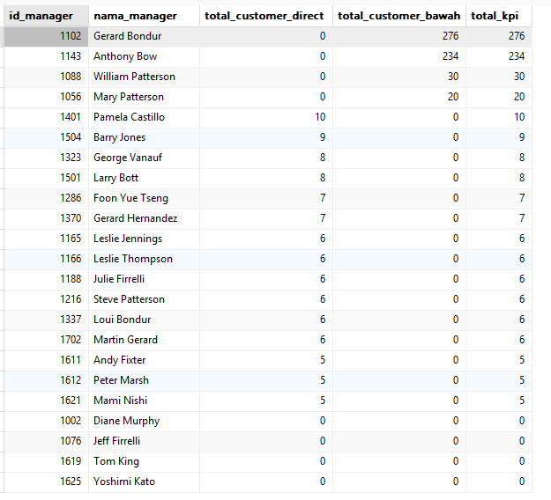

1. **Analisa kembali data LegendVehicle untuk mendapatkan ranking pegawai berdasarkan KPI "Jumlah omset yang didapat". Urutkan ranking pegawai beserta keterangan dana yang didapat!**

SELECT

e.employeeNumber AS id_pegawai,

CONCAT(e.firstName, ' ', e.lastName) AS nama_pegawai,

COALESCE(SUM(p.amount), 0) AS total_omset

FROM employees e

LEFT JOIN customers c ON e.employeeNumber = c.salesRepEmployeeNumber

LEFT JOIN payments p ON c.customerNumber = p.customerNumber

GROUP BY e.employeeNumber

ORDER BY total_omset DESC;

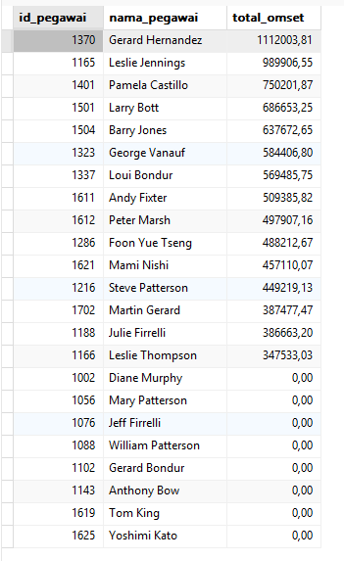

1. **Jika KPI yang pertama merupakan "Jumlah customer yang bertransaksi" sedangkan KPI yang kedua "Jumlah omset yang didapat". Maka, berapakah jumlah field yang dibutuhkan untuk mendapatkan informasi tersebut?**

SELECT

e.employeeNumber,

CONCAT(e.firstName, ' ', e.lastName) AS employeeName,

COUNT(DISTINCT c.customerNumber) AS total_customers,

SUM(p.amount) AS total_revenue

FROM employees e

LEFT JOIN customers c ON e.employeeNumber = c.salesRepEmployeeNumber

LEFT JOIN payments p ON c.customerNumber = p.customerNumber

GROUP BY e.employeeNumber

ORDER BY total_revenue DESC;

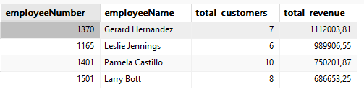

|  |  |
| --- | --- |
| **KPI** | **Jumlah Field** |
| Jumlah customer yang bertransaksi | **1** (COUNT DISTINCT customerNumber) |
| Jumlah omset yang didapat | **1** (SUM(amount)) |

1. **Buatlah report pertahun untuk KPI "Jumlah omset yang didapat" pada Foon Yue Tseng dan Pamela Castillo. Serta gambarkan grafiknya (grafik garis).**

SELECT

e.employeeNumber,

CONCAT(e.firstName, ' ', e.lastName) AS employeeName,

YEAR(p.paymentDate) AS tahun,

SUM(p.amount) AS total_revenue

FROM employees e

JOIN customers c ON e.employeeNumber = c.salesRepEmployeeNumber

JOIN payments p ON c.customerNumber = p.customerNumber

WHERE e.firstName IN ('Foon Yue', 'Pamela') AND e.lastName IN ('Tseng', 'Castillo')

GROUP BY e.employeeNumber, YEAR(p.paymentDate)

ORDER BY tahun, total_revenue DESC;

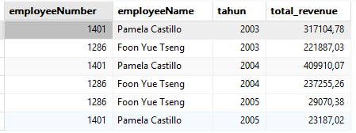

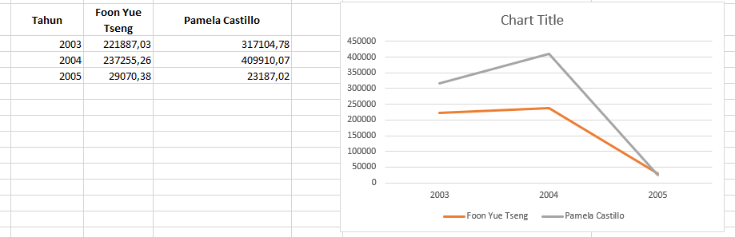

**STUDI KASUS**

Pak Huhut merupakan pemegang saham LegendVehicle. dia membutuhkan dashboard untuk melihat perkembangan penjualan (omset) disetiap cabang di tiap tahunnya. Dikarenakan perusahaan tersebut belum merekrut Data Engineer maka, penarikan informasi hanya bisa dilakukan melaluai OLTP yang ada.

Hasil report yang diinginkan adalah grafik berdasarkan tabel berikut:

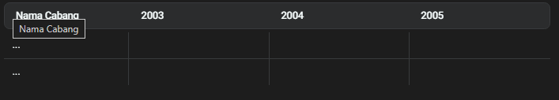

Analisalah terlebih dahulu:

1. Field apa saja yang diperlukan untuk menampilkan penjualan di setiap cabang.

|  |  |  |
| --- | --- | --- |
| **Nama Field** | **Asal Tabel** | **Keterangan** |
| officeCode | offices | Kode unik cabang |
| city | offices | Nama cabang/kota |
| paymentDate | payments | Tanggal pembayaran |
| amount | payments | Total transaksi |
| customerNumber | customers | ID pelanggan |
| salesRepEmployeeNumber | customers | ID sales representative |
| employeeNumber | employees | ID karyawan/sales |
| officeCode | employees | Cabang tempat sales bekerja |

1. 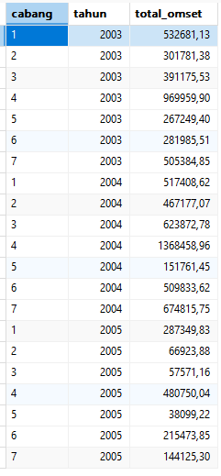Bentuk query dengan memperhatikan relasi antar tabel.

SELECT

b.officeCode AS cabang,

YEAR(p.paymentDate) AS tahun,

SUM(p.amount) AS total_omset

FROM payments p

JOIN customers c ON p.customerNumber = c.customerNumber

JOIN employees e ON c.salesRepEmployeeNumber = e.employeeNumber

JOIN offices b ON e.officeCode = b.officeCode

GROUP BY b.officeCode, YEAR(p.paymentDate)

ORDER BY tahun, cabang;

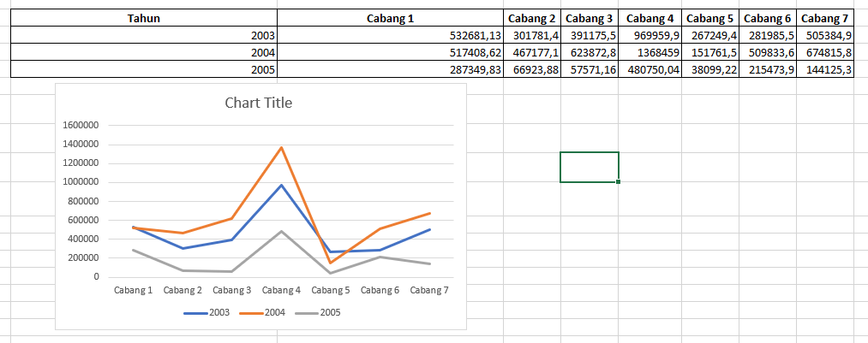

**SOAL BONUS**: buatlah report lain dengan sumber data OLTP yang sama, analisa field yang digunakan, bentuk struktur query dan tuliskan dalam tabel serta grafiknya.

Report Top 5 Sales dengan Omset Tertinggi

|  |  |  |
| --- | --- | --- |
| **Nama Field** | **Asal Tabel** | **Keterangan** |
| employeeNumber | employees | ID Karyawan |
| firstName + lastName | employees | Nama Sales |
| SUM(amount) | payments | Total omset yang diperoleh |
| YEAR(paymentDate) | payments | Tahun transaksi |

SELECT

e.employeeNumber,

CONCAT(e.firstName, ' ', e.lastName) AS nama_sales,

YEAR(p.paymentDate) AS tahun,

SUM(p.amount) AS total_omset

FROM payments p

JOIN customers c ON p.customerNumber = c.customerNumber

JOIN employees e ON c.salesRepEmployeeNumber = e.employeeNumber

GROUP BY e.employeeNumber, nama_sales, YEAR(p.paymentDate)

ORDER BY tahun, total_omset DESC

LIMIT 5;

